Milestone One
Derick Silva
11/8/2025

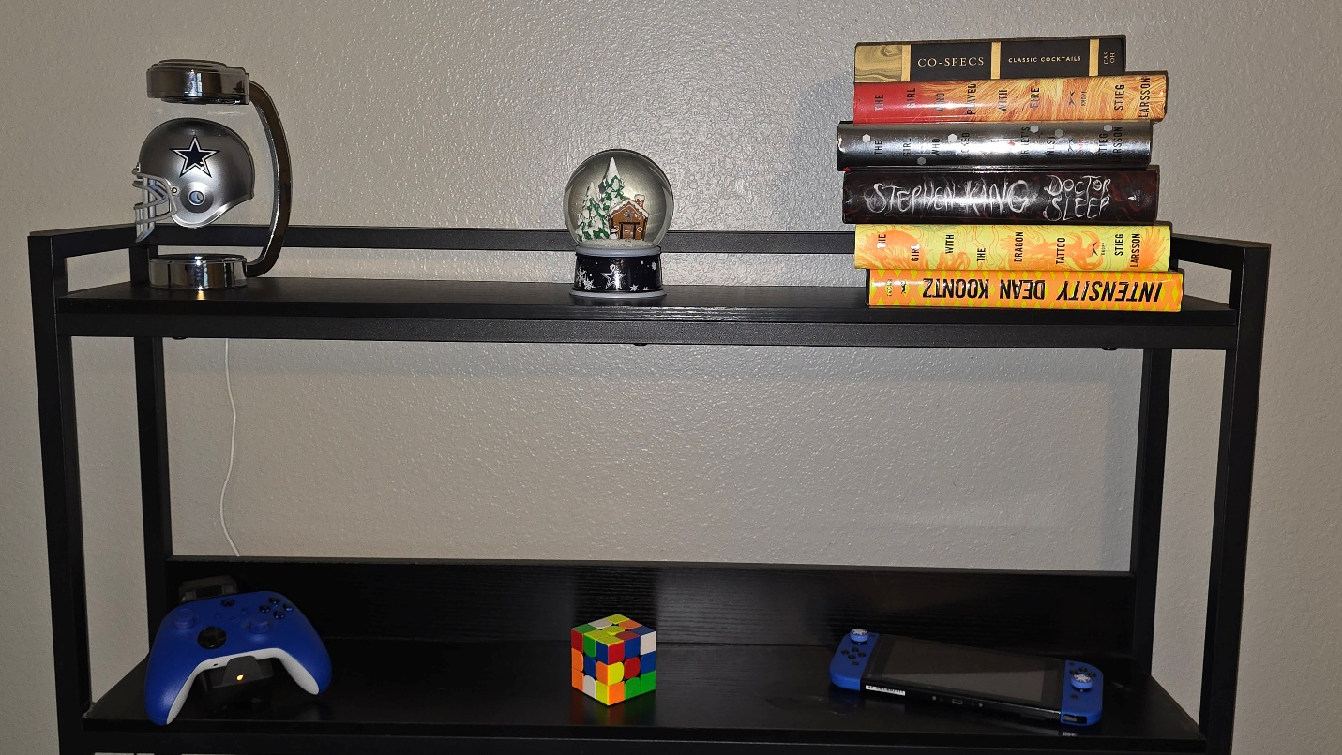
This is the scene I will be recreating in 3D. I will be replicating the NFL helmet and stand in 3D, the snow globe, the stack of books, the Rubik’s cube and the Nintendo Switch. The Rubik’s cube is just a cube, this would be simplest object to recreate. The stack of books is simple at first glance, but if they are to be accurately recreated, the rounded spine can be recreated with a narrow cylinder while a plane can be used for front and back covers. The pages can simply be a rectangle that is sandwiched between the covers. I can create one book and copy and resize it to match the size of each book and orientate them appropriately. The snow globe is a combination of two 3D shapes, the base being a tapered cylinder and the globe is a sphere staked on top of the tapered cylinder.
The Xbox controller is a little more complicated, the hand grips can be done with capsule shape while the main body can be done with a box shape. The joysticks will be cylinders with a concave top and a torus around the top to create the thumb grip. The face buttons (A, B, X, Y) are spheres. The d-pad can be a flattened sphere with two rectangular boxes to form the protruding cross shape. The start and select buttons are capsules and the Xbox logo button is a flattened sphere. The triggers and bumpers would have to be smoothed trapezoids to try and match their shape.
The NFL helmet is a little complicated as well, the main shape can be accomplished using a sphere that is partially flattened to create the dome and stretched from the bottom to create the shape around the ears. The face mask is a combination of torus segments for the horizontal parts and cylinders for the vertical parts. The top and bottom of the stand are flattened cylinders and the arm connecting them can be a torus section.
The Nintendo Switch can basically be a rectangular box with rounded corners and flattened. The buttons and joysticks can be done in the same fashion as the Xbox controller, face buttons with spheres, joysticks with cylinders topped with torus’.
The shelves can be planes which all the objects will be placed on. This gives a common grounding point for each object on the shelves.

